**Simple portfolio website creation:**

For php web development require 2 software.

1)**visual studio**

2)**xampp:**it is web server solution package generally used in order to manage database and create local web server.

1. Download both software and install it.

**How to install Visual Studio**

Step1: Download Visual Studio

Step2: Double click the downloaded file

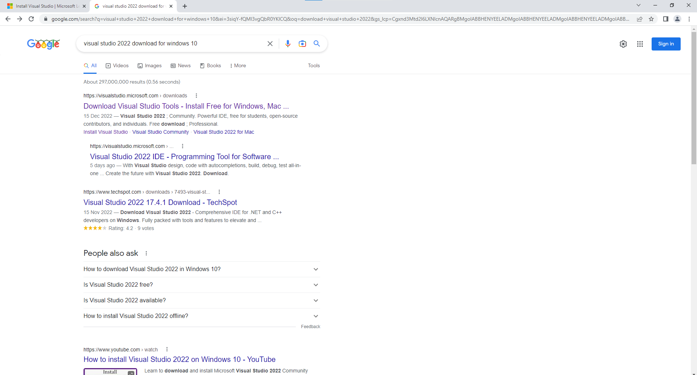

Click the first link

Step3: click **free download** from **Community**.

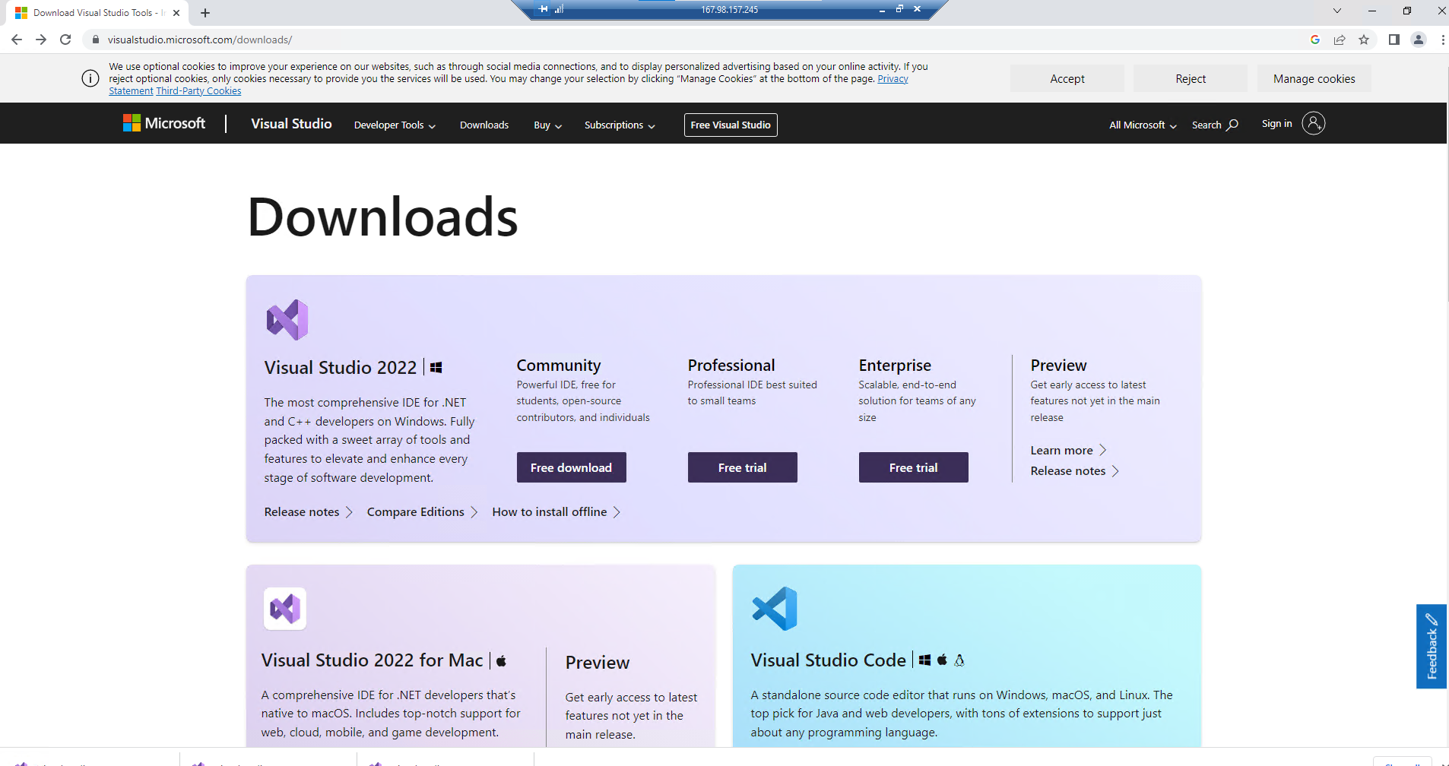

Step4: double click the downloaded file from downloads.

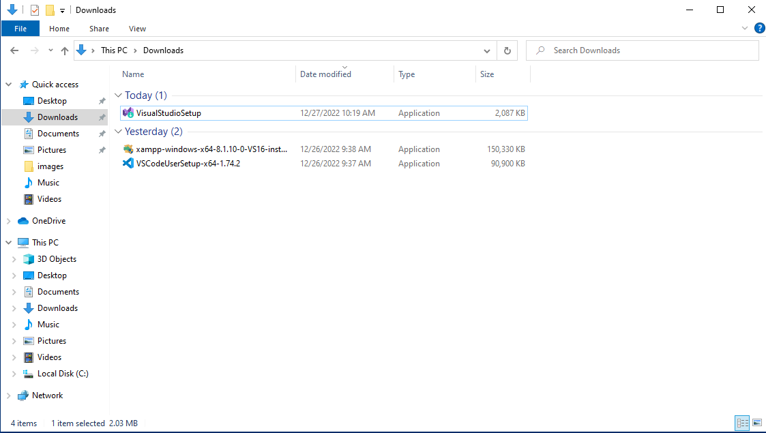

Step5: Then click ’yes’

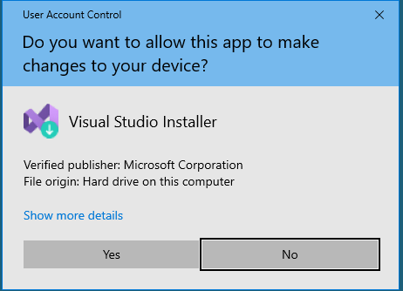

Step6: click continue.

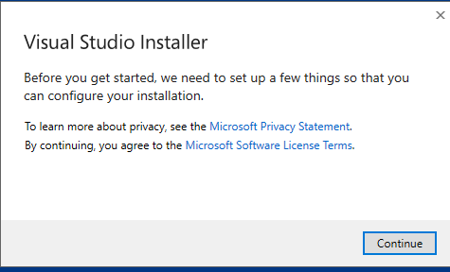

Step7: click the install button

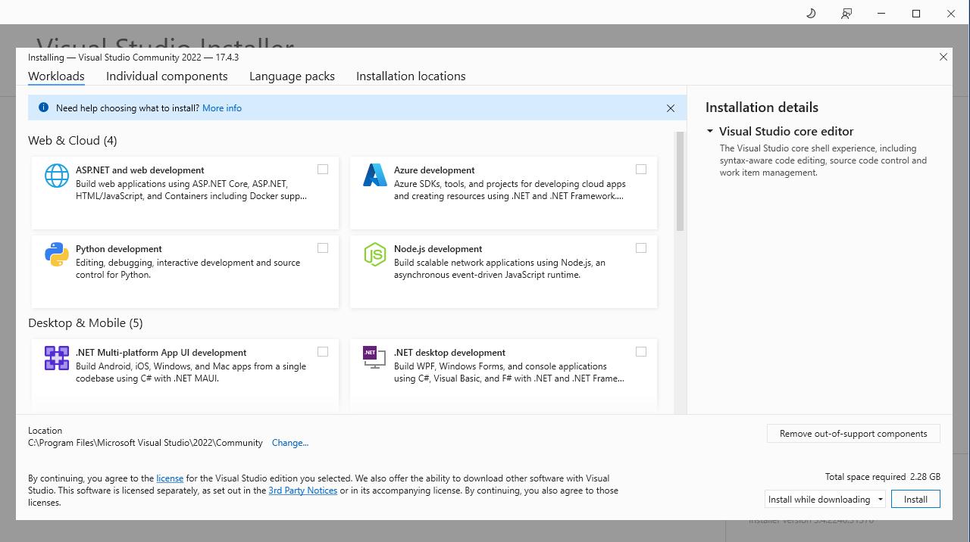

Step8: click the continue button

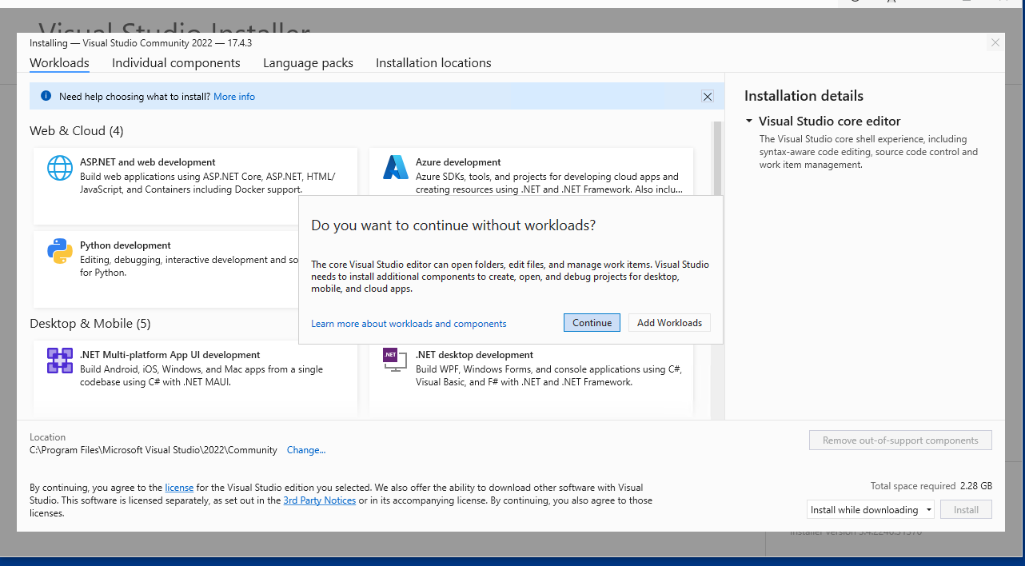

Step9: then click **start visual studio**

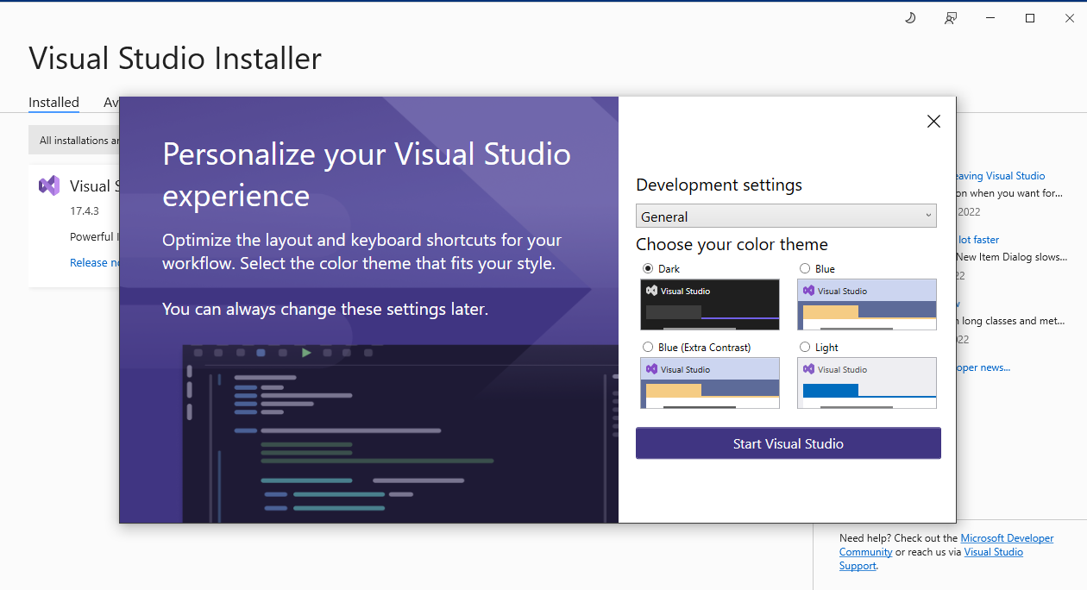

Now visual studio will appear in your screen.

**How to install xampp on Windows 10**

Step1: Open the link <https://www.apachefriends.org/download.html>

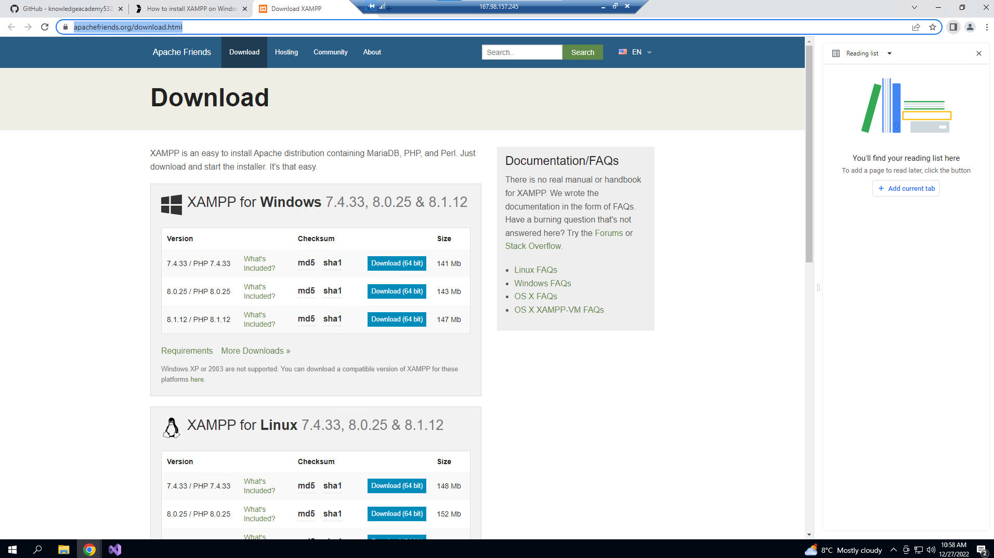

Step2: Click the **Download** button for the Windows version of XAMPP and save the file on your computer.

Step3: Double-click the downloaded file to launch the installer.

Step4: Click the **OK** button.

Step5: Click the **Next**button.

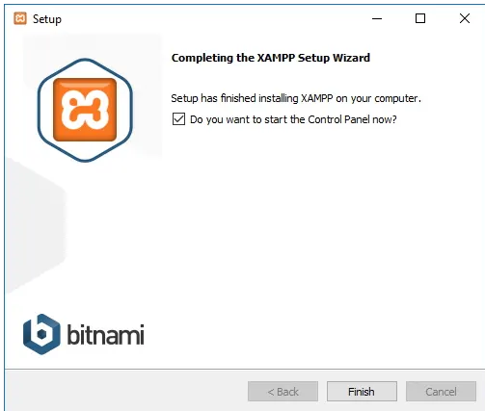

XAMPP offers various components that you can install, such as MySQL, phpMyAdmin, PHP, Apache, and more. For the most part, you will be using most of these components, which means that it is recommended to leave the default options.

Step6: Click the **Next**button.

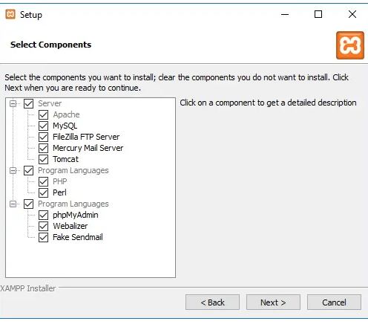

Step7: Use the default installed options.

Step8: Click the Next button

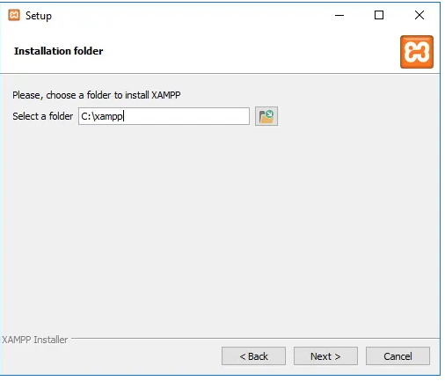

Step9: Select the language for the XAMPP Control Panel.

Step10: Click the **Next** button.

Step11: Clear the **Learn more about Bitnami for XAMPP** option.

Step12: Click the **Next** button.

Step13: Click the Next button again.

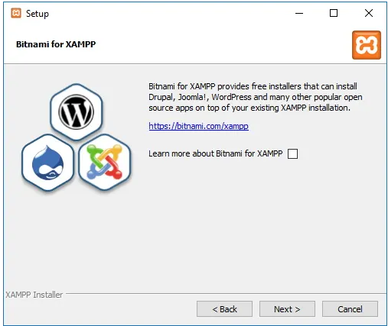

Step14: Click the **Allow access** button to allow the app through the Windows Firewall

Step15: Click the **Finish** button.

Once you complete the steps xampp will appear in our system.

Now we installed xampp and visual studio in our system. Next step is to create the project.

1. Our project folder should create inside this **C:\xampp\htdocs**
2. Create a folder named **portfolio** inside C:\xampp\htdocs
3. Then create a folder **css** and **images.**

In **css** folder we can store css file and images we can store in **images** folder.

We can also create a **js** folder for store js file.

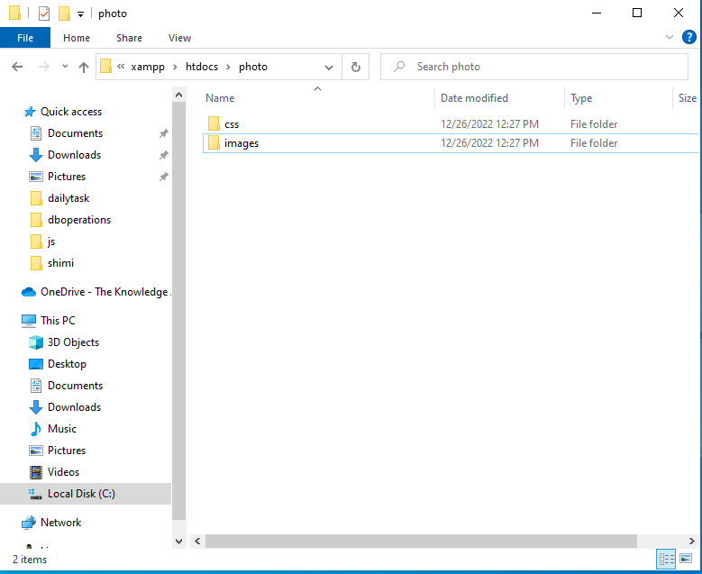

1. Open the folder **portfolio** in visual studio
2. then create a file **index.php**
3. type **shift+!** Automaticallywill come the html tags.

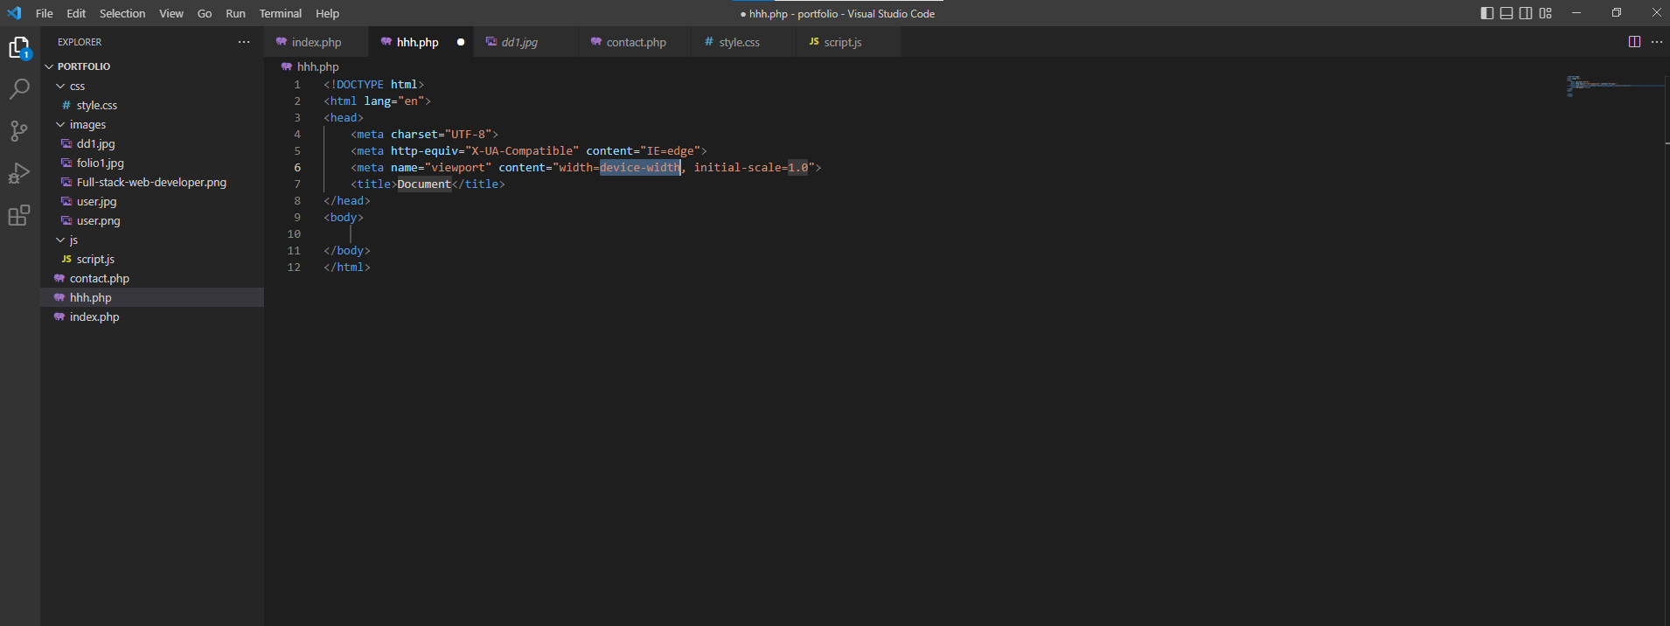

**<! DOCTYPE html>:** The doctype should define the page as an HTML5 document:

**<meta charset="UTF-8">:** A meta tag should define the character set to be UTF-8

**<meta name="viewport" content="width=device-width, initial-scale=1">:**

A viewport meta tag should make the web site work on all devices and screen resolutions.

The width=device-width part sets the width of the page to follow the screen-width of the device.

The initial-scale=1 part sets the initial zoom level when the page is first loaded by the browser.

**What is Bootstrap?**

* Bootstrap is a free front-end framework for faster and easier web development
* Bootstrap includes HTML and CSS based design templates for typography, forms, buttons, tables, navigation, modals, image carousels and many other, as well as optional JavaScript plugins
* Bootstrap also gives you the ability to easily create responsive designs

We used **bootsrap4** in order project.

There are two ways to start using Bootstrap 4 on your own web site.

You can:

* Include Bootstrap 4 from a CDN
* Download Bootstrap 4 from getbootstrap.com

**jsDelivr** provides CDN support for Bootstrap's CSS and JavaScript.

**We** used first way. That is **include Bootstrap from a CDN:**

The following are 4 links used in our project

<!-- Latest compiled and minified CSS -->  
<link rel="stylesheet" href="https://cdn.jsdelivr.net/npm/bootstrap@4.6.2/dist/css/bootstrap.min.css">  
  
<!-- jQuery library -->  
<script src="https://cdn.jsdelivr.net/npm/jquery@3.6.1/dist/jquery.slim.min.js"></script>  
  
<!-- Popper JS -->  
<script src="https://cdn.jsdelivr.net/npm/popper.js@1.16.1/dist/umd/popper.min.js"></script>  
  
<!-- Latest compiled JavaScript -->  
<script src="https://cdn.jsdelivr.net/npm/bootstrap@4.6.2/dist/js/bootstrap.bundle.min.js"></script>

Advantage of using the Bootstrap 4 CDN:  
Many users already have downloaded Bootstrap 4 from jsDelivr when visiting another site. As a result, it will be loaded from cache when they visit your site, which leads to faster loading time. Also, most CDN's will make sure that once a user requests a file from it, it will be served from the server closest to them, which also leads to faster loading time.  
  
jQuery and Popper?  
Bootstrap 4 uses [jQuery](https://www.w3schools.com/jquery/default.asp) and Popper.js for JavaScript components (like modals, tooltips, popovers etc.). **However**, if you just use the CSS part of Bootstrap, you don't need them.

After that we can **create navbar**.

add navbar in our project we can use bootstrap navbar. Search the bootstrap navbar through google.

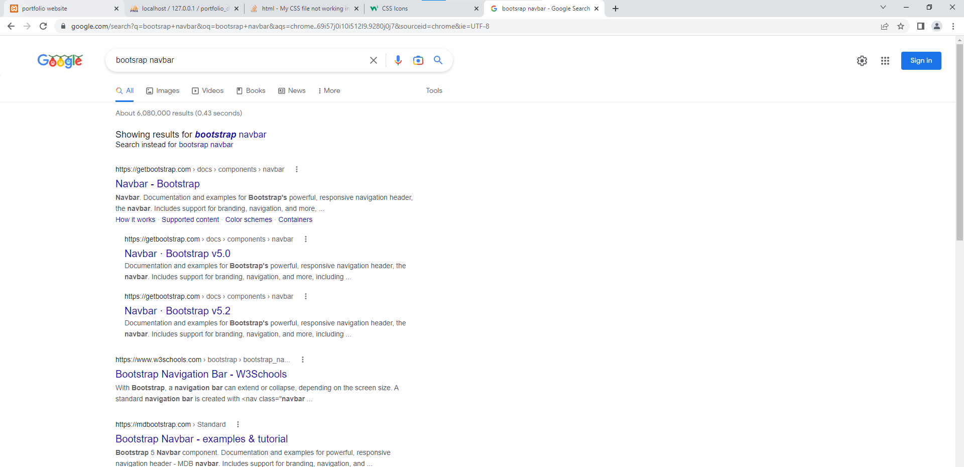

**Click** the first link and get the navbar code from there.

**Next step is to create a link in navbar**

  <a class="nav-link" href="#about">About Me</a>

If we click **About Me then** it will go to about section. href mentioned **#about.**

**#about** is the id of **div** tag in **about** section

<div id="about">

<h2 class="text-center">About me</h2>

    <div class="text-center">

      <img src="images/user.jpg" alt="Mike" style="width:200px;">

      <div  >

        <h2 style="color:orange;">John Marchas</h2>

        <p class="title">Fullstack developer</p>

        <p>Fullstack Web developer proficient in fundamental front-end languages and server side languages.In depth knowledge of Mysql,MongoDB and Oracle.</p>

         <p>Analytical and precise professional with 5 years of hands on experience talking charge of front and backend web development.</p>

        <p style="color:blue;">john.marchas@theknowledgeacademy.com</p>

        <p></p>

      </div>

    </div>

  </div>

**Footer color changing using css**

**In index.php** file

 <section class="footer1">

Style.css

.footer1{

background-color: beige;

}

The output of footer should be look like as following

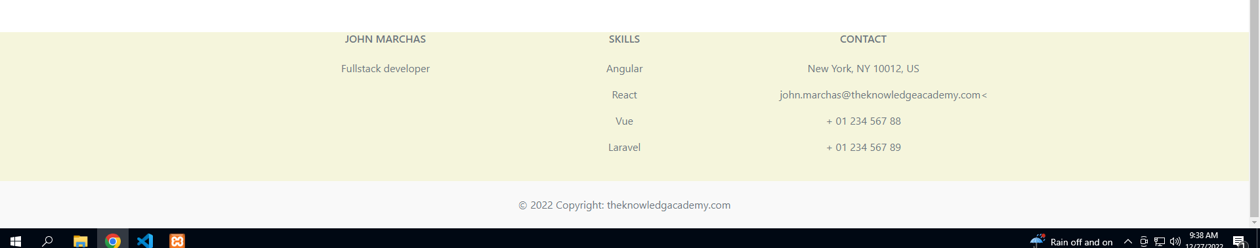

**Use java script to slides the image each time interval**

1. first create folder **js** inside our project portfolio
2. create file script.js inside js folder. Inside the file write the following code.

var myIndex = 0;

carousel();

function carousel() {

  var i;

  var x = document.getElementsByClassName("slides");

  for (i = 0; i < x.length; i++) {

    x[i].style.display = "none";

  }

  myIndex++;

  if (myIndex > x.length) {myIndex = 1}

  x[myIndex-1].style.display = "block";

  setTimeout(carousel, 3000);

}

**And** use the following line in our index.php

<script src="js/script.js"></script>

**Normally script link always writes before </body> tag.**

**Save contact form data into MySQL database**

First we should write a following code in index.php

<section class="my-4" id="contact">

<div class="py-4">

<h2 class="text-center">Contact Me</h2>

</div>

<div class="w-50 m-auto">

<form action="contact.php" method="post">

  <div class="form-group">

    <label>Name:</label>

<input type="text" name="name" class="form-control"> </div>

<div class="form-group">

    <label>Email:</label>

<input type="text" name="email" class="form-control"> </div>

<div class="form-group">

    <label>Number:</label>

<input type="textarea" name="number" class="form-control"> </div>

<div class="form-group">

    <label>Description:</label>

<input type="text" name="description" class="form-control"> </div>

<button type="submit" class="btn btn-success">Submit</button>

</form>

</section>

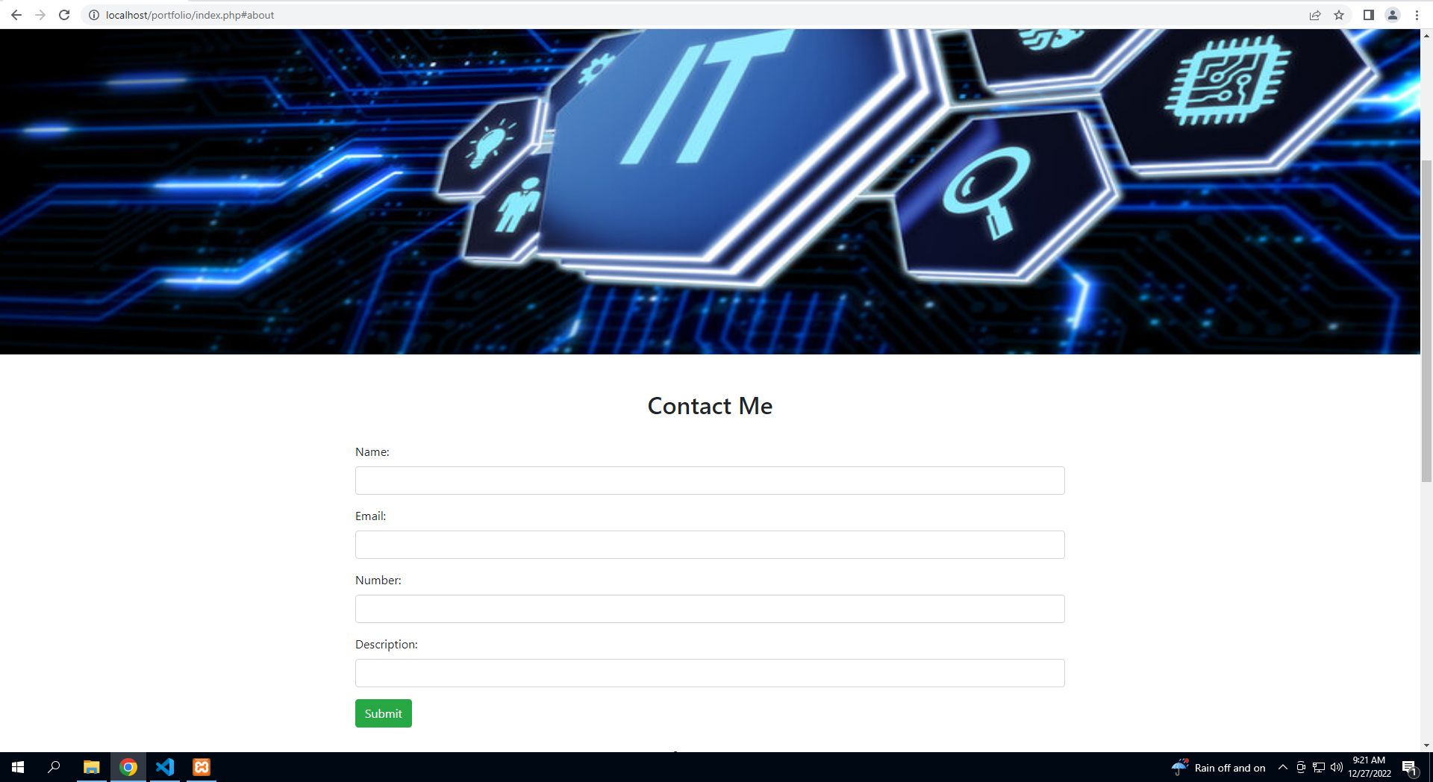

Next Create a file **contact.php** and write thefollowing code

<?php

$con=mysqli_connect('localhost','root');

if($con)

{

    echo "Connection successfull";

}

else{

    echo "Connection failed";

}

mysqli_select_db($con,'portfolio_db');

$name=$_POST['name'];

$email=$_POST['email'];

$number=$_POST['number'];

$des=$_POST['description'];

$query="insert into users(name,email,number,description)values('$name','$email','$number','$des')";

mysqli_query($con,$query);

header('location:index.php')

?>

Then do the following database part.

**we should** create a database inside MySQL

1. Open xampp and start apache and MySQL

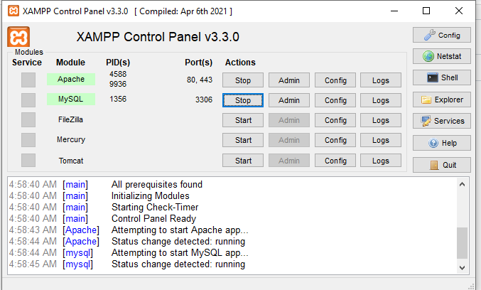

1. **Open** browser and type localhost/phpmyadmin/
2. Then create a database **portfolio_db**
3. Create a table name **users** and fields are

id, name, email, number and description

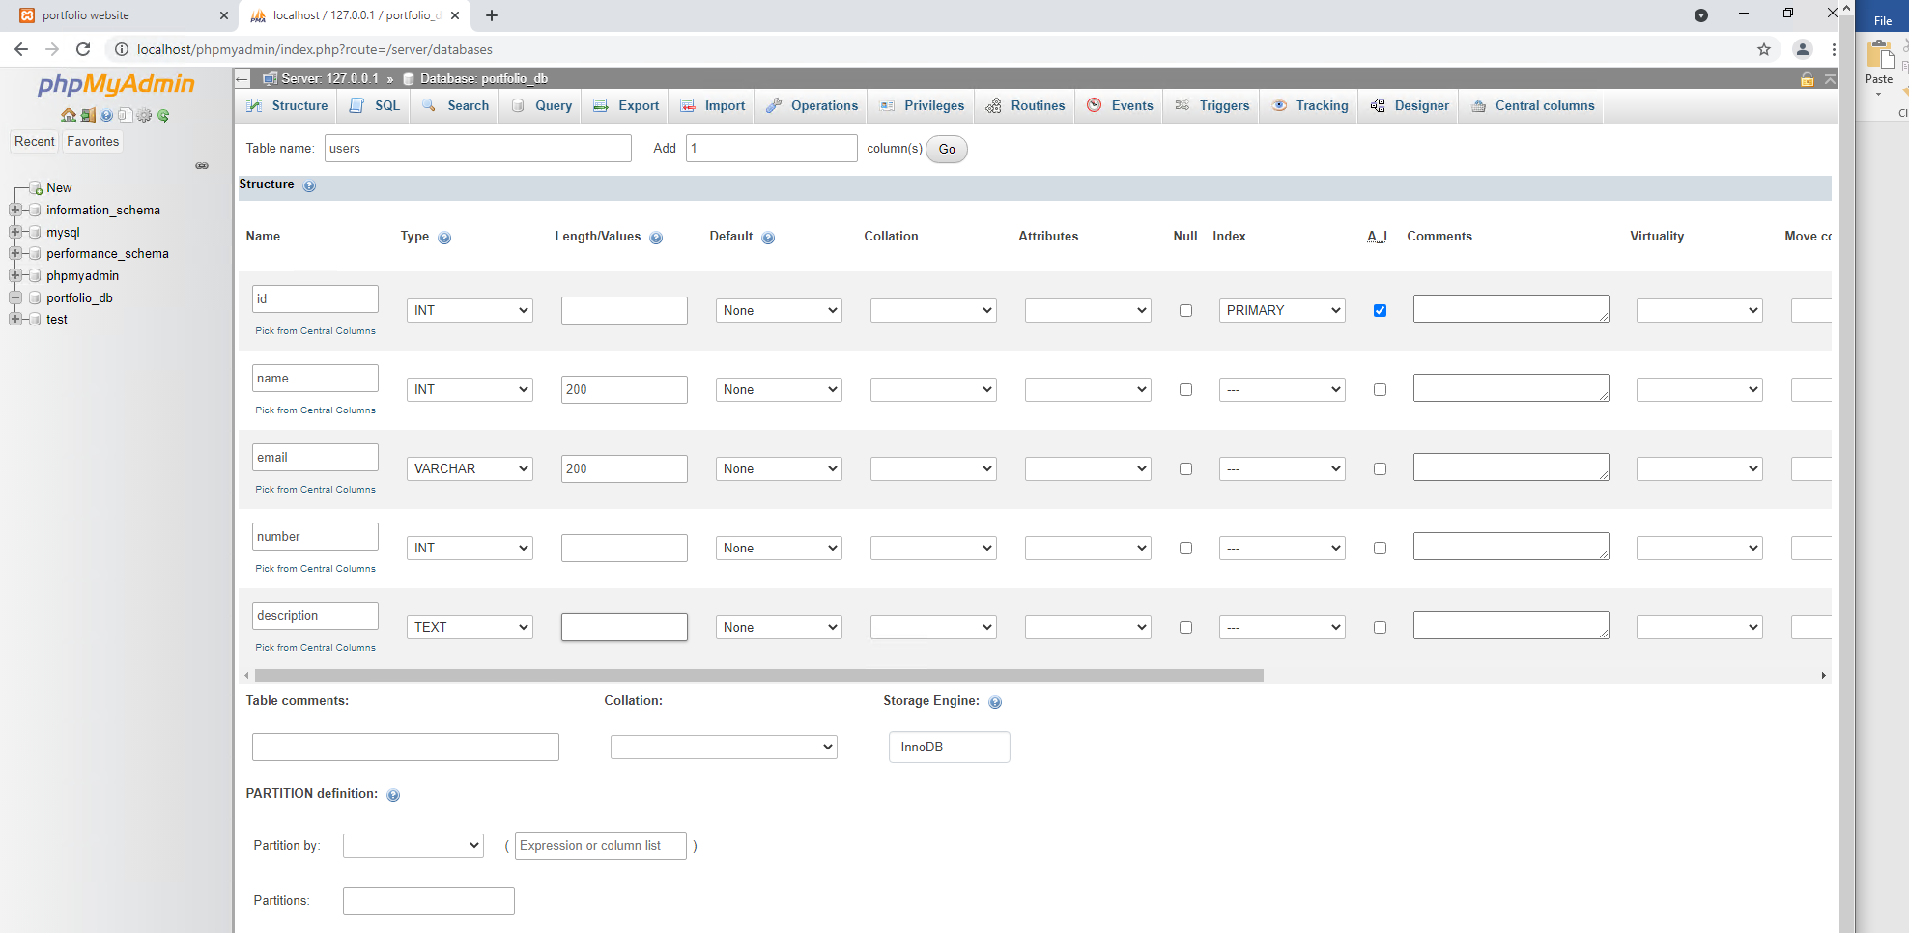

Then the output should be look like as

Aftr

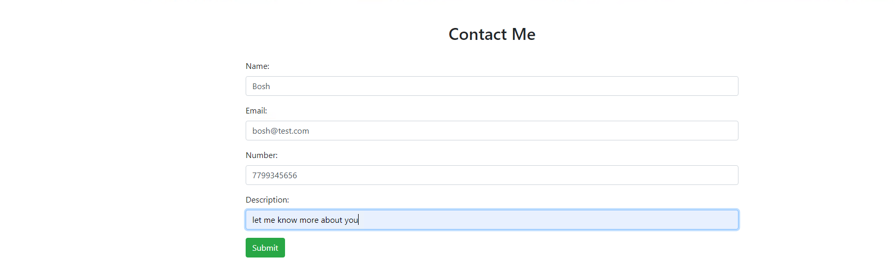

After click submit button the data will be stored in database. The data base is look like as following:

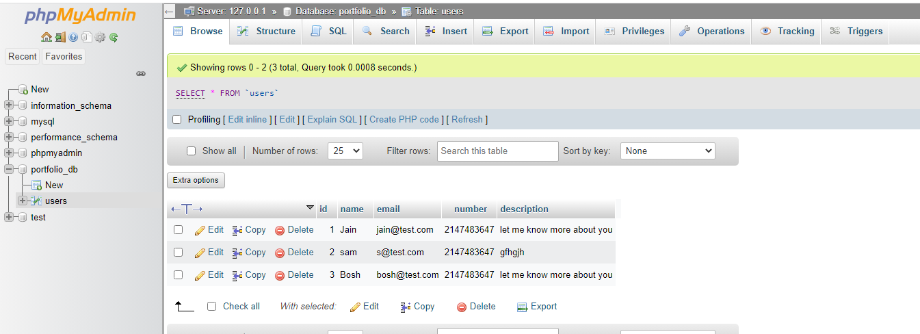

Our final website should be like as

Navbar with image

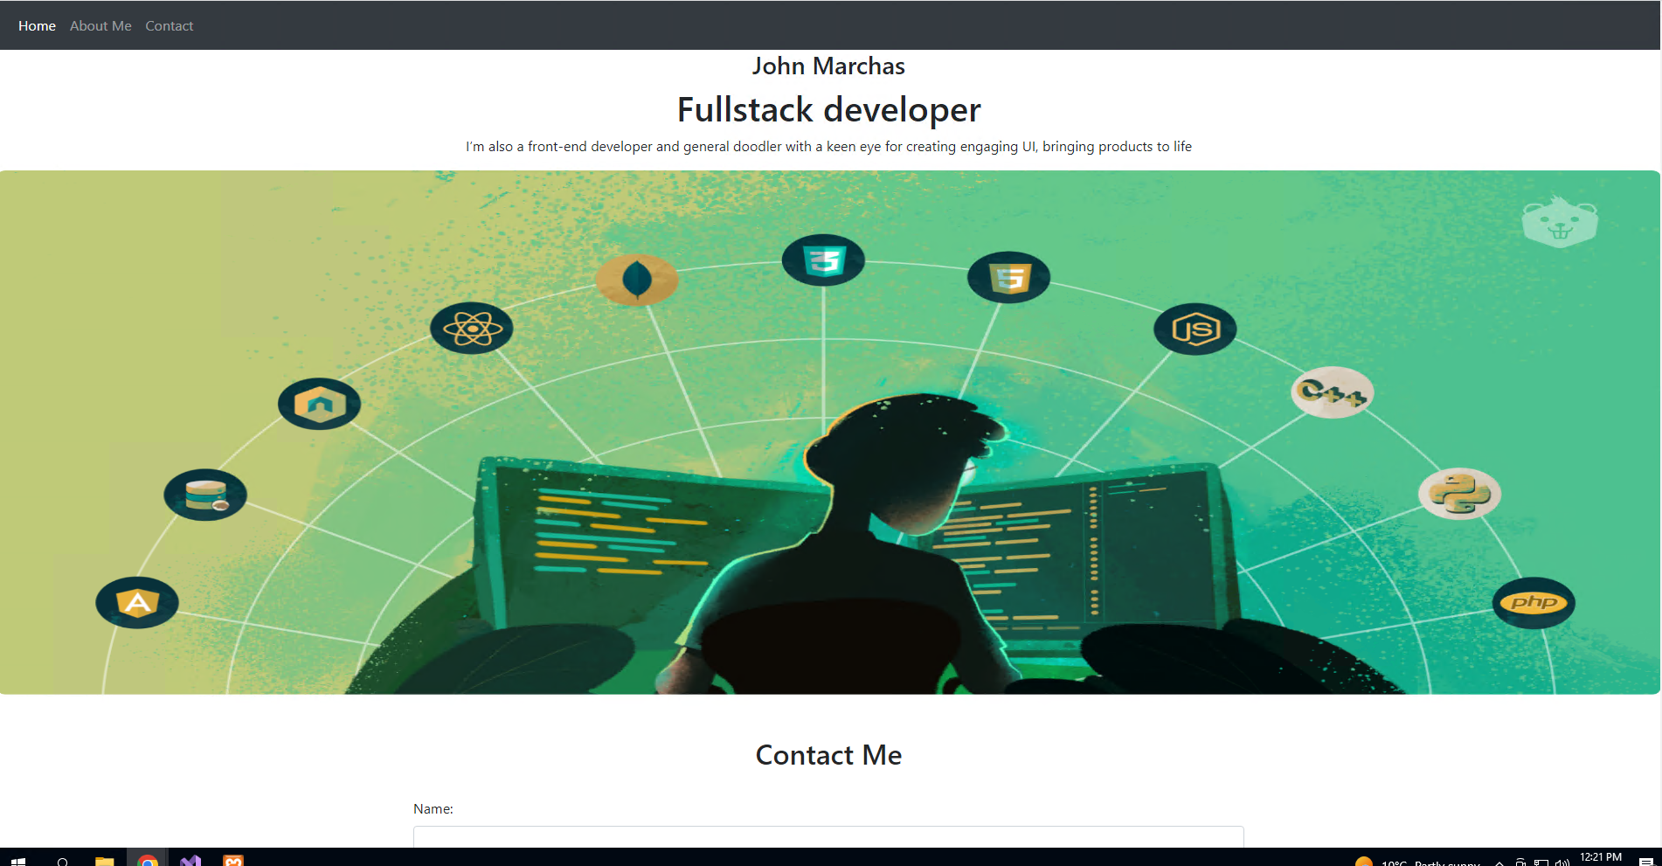

Contact section

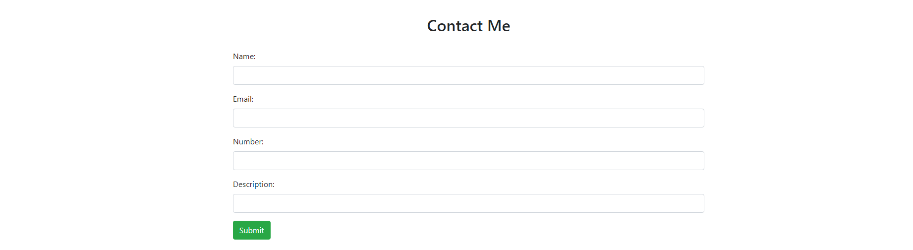

About section



Footer section



This is the GitHub slink **https://github.com/knowledgeacademy532/Portfolio**